**Toiletrie 24**

User’s Manual

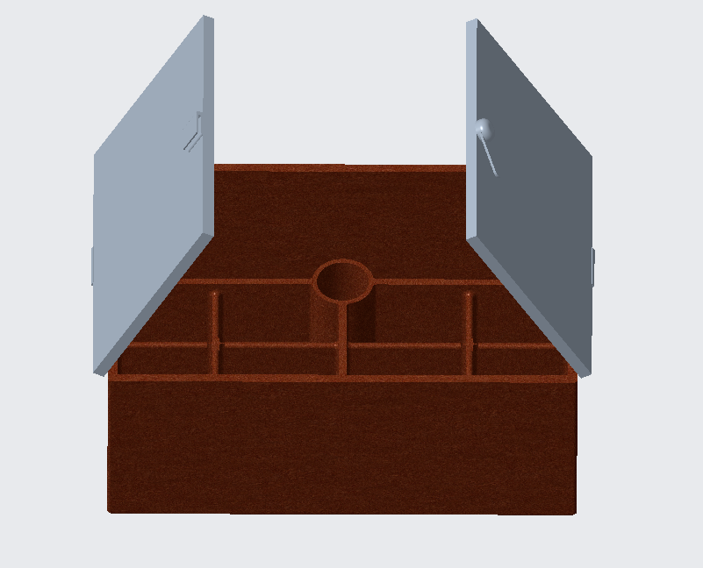

**Parts List:**

* C-Top Lids ($10.00)

* Lever ($3.00)

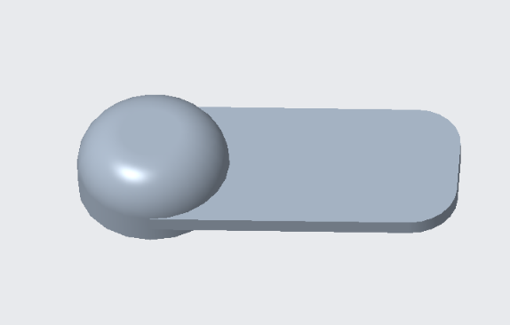

* Toothbrush Holder ($15.00)

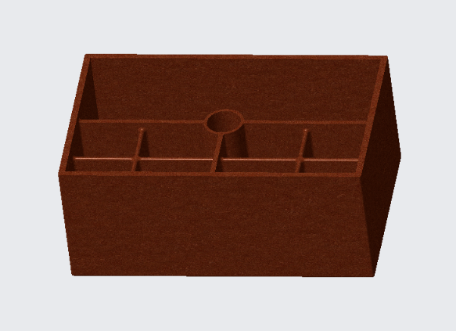

* Hinges ($3.00)

**Assembly:**

1. Attach **Hinges** to sides of **Toothbrush Holder**

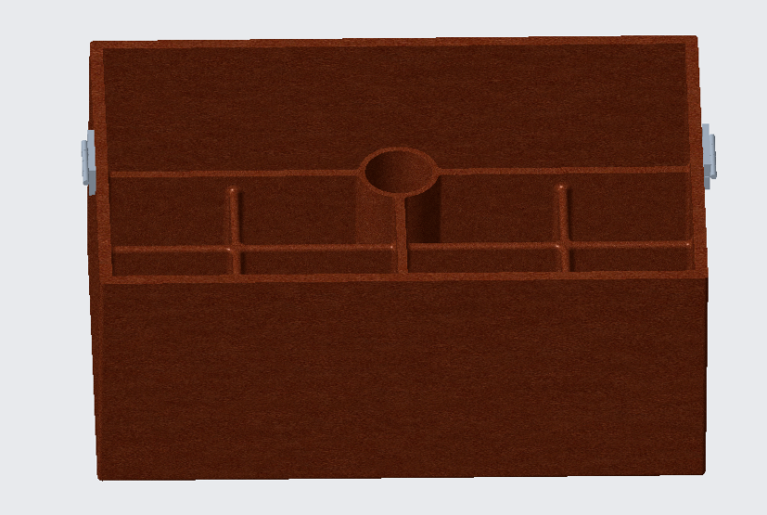

1. Attach **C-Top Lids** to **Hinges**

1. Attach **Lever** to **C-Top Lid**

**Use and Maintenance:**

* Toiletrie 24 uses:
  + Toiletry storage

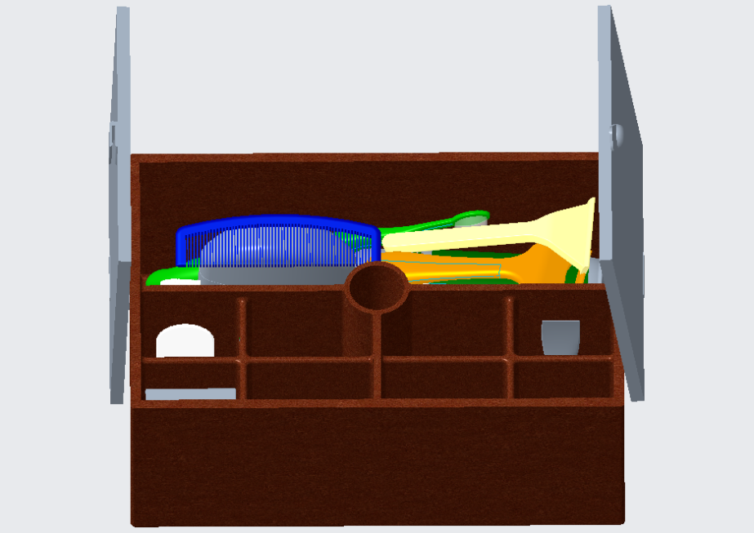

* + Toiletry holder

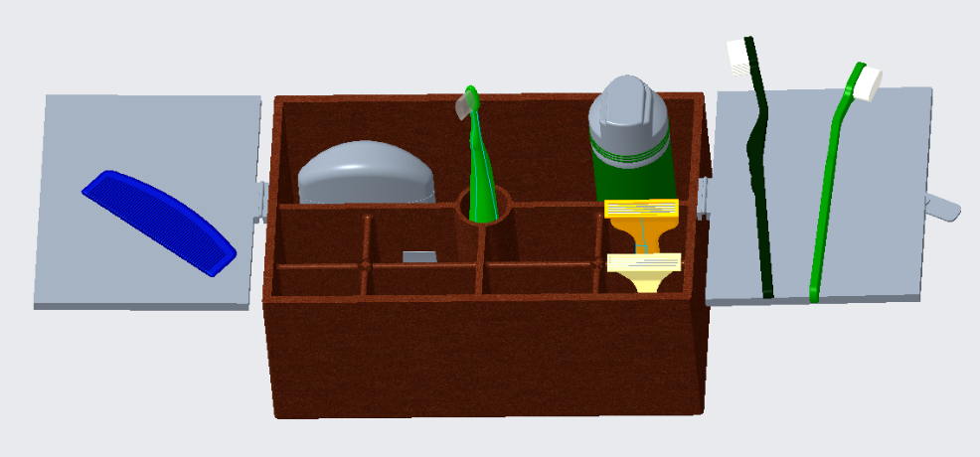

* Maintenance:
  + Washing:
    - Wash thoroughly with warm soapy water after each use
    - Rinse with cool water
    - Allow to dry for 3-4 hours
  + If broken:
    - See warranty information

**Part Maintenance:**

* Replacement parts can be purchased from manufacturer (part cost included in warranty)
* See assembly for replacement instructions

**OR**

* Receive free repair from manufacturer (recommended)
* Recommended to only use official parts from manufacturer

**Warranty:**

* Our product offers two warranty options:
  + Customary Warranty
    - Lasts 1 year from purchase
    - Costs $30.00
  + Extended Warranty
    - Lasts 4 years from purchase
    - Costs $45.00
* All warranties include:
  + Part costs
  + Repairs

**Service Center:**

* 9201 University City Blvd

Charlotte, NC

28223

* Number: 1(800) CDE-4949
* Representatives:
  + Cameron Gantert ([cgantert@uncc.edu](mailto:cgantert@uncc.edu))
  + Danny Trevino ([dtrevino@uncc.edu](mailto:dtrevino@uncc.edu))
  + Ethan Hartman ([ehartma6@uncc.edu](mailto:ehartma6@uncc.edu))